INTRODUCTION
Communication satellites are artificial satellites placed in space to relay and amplify radio, television, internet, and telephone signals between different locations on Earth. They act as space-based repeaters, receiving signals from one ground station and transmitting them to another, often over long distances that would be difficult to cover with terrestrial systems.
A typical communication satellite consists of:
- Transponders – devices that receive, amplify, and retransmit signals.
- Antennas – for receiving and sending electromagnetic waves.
- Power systems – usually solar panels and batteries.
- Control systems – for maintaining proper orientation and orbit.
Satellites are positioned in various orbits such as:
- Geostationary Orbit (GEO) – about 36,000 km above the equator; the satellite appears fixed over one spot on Earth.
- Medium Earth Orbit (MEO) – used for navigation systems like GPS.
- Low Earth Orbit (LEO) – closer to Earth; used for satellite phones and internet (e.g., Starlink).
Communication satellites are essential for:
- Television broadcasting
- Internet connectivity
- Mobile and fixed communication
- Military and weather comm

Communication Satellites
Communication satellite acts as repeater stations that provide either point to point, point to multipoint or multipoint interactive services.
Communication related applications:
Telecommunication satellites provide a varied range of services mainly including
- Television broadcasting
- International telephony and
- Data communication services.
Satellite TV refers to the use of satellites for relaying TV programs from a point where they originate to a large geographical area. Geo satellites are employed for satellite TV applications via TVRO (Television Receive Only) and DBS (Direct Broadcast System).
Satellite telephony provides long distance point-to-point or trunk telephony services, as well as mobile telephony services.
Satellite also provides data communication services including data broadcast and multimedia services such as data collection and broadcasting, image and video transfer, voice, internet, two-way computer interactions and database inquiries.
Broadcasting services like TV, radio and telephony services remain in domain of Geo satellites & newer services like messaging, voice, fax, data & video conferencing suited to LEO, MEO or HEO satellite constellation.

Frequency bands:
Satellite communication employs EM waves for transmission of information between Earth and space. Various bands used in satellite communication include L, S, C, X, Ku, K & Ka.

Payloads:
Transponder is the key payload for any communication satellite.
Basic elements of satellite communication system are depicted below.
Figure 4.1 Basic elements of a satellite communication system
The information to be transmitted (voice channels for telephone service, a composite video signal or digital data) is modulated using analog or digital means, up-converted to its desired microwave frequency band, amplified to the required level and then beamed up to the satellite from the transmitting earth station.
The received signals are amplified by the satellite, down converted to a different frequency and then re-transmitted towards Earth. The device on board satellite performs amplification and frequency conversion known as transponder is the main payload for any communication satellite.
Satellites carry a number of these transponders varying from 10 to as many as 100 on high-capacity satellites.

Types of transponders:
Transponders may be broadly classified into the following types:
- Transparent or bent pipe transponders
- Regenerative transponders
Transparent or bent pipe transponders
This type of transponder provides only amplification, frequency translation and frequency re-translation. The modulation and spectral shape of the signals are not altered, as they simply transmit information back to earth. (Also referred as bent pipe transponders).
The full bandwidth is separated into channels by band-pass radio frequency filters.
The output of filters is amplified by separate power amplifiers (TWTA) and then combined and fed to common transmitting antennas for down-beaming the signals on the Earth.
Figure 4.2 Transparent transponders
Regenerative transponders:
Here some onboard processing is done and the received signal is altered before transmission.
The onboard processing helps to improve throughput and error performance.
The repeaters use various digital techniques like narrowband channel selection, routing, demodulation, error correction, separating of data for processing the received signal.

Satellite vs Terrestrial Network
The advantages of satellite over terrestrial network:
- Broadcast property – wide coverage area
- Wide bandwidth – high transmission speed & large transmission capacity
- Geographical flexibility – independence of location
- Easy installation of ground stations
- Uniform service characteristics
- Immunity to natural disasters
- Independence from terrestrial infrastructure
- Cost aspects – low cost per added station and distance-insensitive cost
Disadvantages w.r.t. terrestrial networks:
- Transmission delay
- Echo effects
- Launch & satellite cost
Satellite telephony:
Satellite provides both long distance point-to-point trunk telephony services as well as mobile Potential uses of these services include people living in remote areas, international business travellers. Satellite telephone networks employ point-to-point duplex satellite links enabling simultaneous communication in both directions.

Figure 4.3 Satellite point-to-point telephone networks (PBX, private branch exchange; PSTN, public switched telephone network)

Satellite TV
Satellite television is the most widely used and talked about application area of communication
satellites. In fact, it accounts for about 75%of the satellite market for communication services.
Satellite television basically refers to the use of satellites for relaying TV programmes from
a central broadcasting centre to a large geographical area. Satellites, by their very nature of
covering a large geographical area, are perfectly suited for TV broadcasting applications. As
an example, satellites like GE and Galaxy in the US, Astra and Hot Bird in Europe, INSAT
in India and JCSAT (Japanese communications satellite) and Superbird in Japan are used for
TV broadcasting applications. The five Hot Bird satellites provide 900 TV channels and 560
radio stations to 24 million users in Europe. Other means of television broadcasting include
terrestrial TV broadcasting and cable TV services. Satellites can provide TV transmission
services either directly to the users or in conjunction with the cable and terrestrial broadcasting
networks. This will be explained in detail in the paragraphs to follow.

4.1.1 A Typical Satellite TV Network
Satellite television employs GEO satellites acting as point-to-multipoint repeaters receiving
a certain telecast from the transmission broadcasting centre and retransmitting the same after
frequency translation to the cable TV operators, home dishes, etc., lying within the footprint of
the satellite. Satellites can provide TV programmes either directly to the users (direct-to-home
television) or indirectly with the help of cable networks or terrestrial broadcasting networks,
where the satellite feeds the signal to a central operator who in turn transmits the programmes
to the users either using cable networks or through terrestrial broadcasting. A typical satellite
TV network, like any other satellite network, can be divided into two sections: the uplink
section and the downlink section.

Figure 4.4 Uplink section of satellite TV networks
The uplink section (Figure 4.4) comprises three main components: the programming source,
the broadcasting centre and the main broadcasting satellite. The programming source comprises
TV channel networks, cable TV programmers, etc., that provide various TV programming
signals, like TV channels, sports coverage, news coverage or local recorded TV programmes, tothe broadcasting centre either through terrestrial means, like using the line-of-sight microwave
communication and the fibre optic cable, or using satellites referred to as back-haul satellites.
As an example, for one-time events like various news events, a vehicle-mounted Earth station
generally operating in theKu band is driven to the site and then the programmes are transmitted
to the main broadcast centre using a back-haul satellite on a point-to-point connectivity basis
[known as satellite news gathering (SNG)]. In the case of a live telecast of certain events like
sports, the signals picked up by the cameras are transmitted to the main broadcasting centre
either with the help of a microwave link, a fibre optic link or a point-to-point backhaul satellite
link. The broadcasting centre is the hub of the satellite TV system and it processes and beams
the signal to the main broadcasting satellite. It also adds commentary or advertisements to the
signals from the various programming sources. Generally, the signals are transmitted using
analogue techniques in the C band or using a digital format employing various compression
techniques in the Ku band. The signals are also generally encrypted before transmission to
prevent unauthorized viewing.
The satellite downlink comprises the main broadcasting satellite and the TV receiving network.
In fact, the main broadcasting satellite is common in both the uplink and the downlink
sections. The receiver network in the case of satellites distributing programmes to the terrestrial
broadcast network comprises various terrestrial broadcasting centres that receive the satellite
signal and transmit them to the users in the VHF and the UHF bands using terrestrial broadcasting.
The user end has directional yagi antennas to pick up these signals. In the case of satellite
distributing programmes to a cable operator, the downlink section comprises the cable–TV
head ends and the cable distribution network. For DTH services, receive-only satellite dishes
are mounted at the user’s premises to receive the TV programmes directly from the satellite.
4.1.2 Satellite–Cable Television
As mentioned earlier, cable TV refers to the use of coaxial and fibre optic cables to connect
each house through a point-to-multipoint distribution network to the head end distribution
station. Cable TV, originally referred to as CATV (community antenna television) stood for
a single head end serving a particular community, like various houses in a large building.
The present-day cable TV system is more complex and involves a larger distribution area.
The head ends receive programming channels from either a local broadcasting link or through
satellites. The use of satellites to carry the programming channels to the cable systems head
ends is referred to as satellite–cable television (Figure 4.5). The head end in this case consists
of various receive-only Earth stations with the capability of receiving telecast from two to
six satellites. These Earth stations either have multiple receiving antennas or, a single dish
antenna with multiple feeds, with each feed so aligned as to receive telecast from a different
satellite.
The transmission from the satellite is either in the analogue format (mainly in the C band)
or in the digital format (mainly in the Ku band). In analogue format of transmission, each
receiver is tuned to a different transponder channel and the signals from various receivers are

Figure 4.5 Satellite cable television
multiplexed for transmission to the users. The channels received in the digital format can be
transmitted either digitally or in the analogue form as mentioned above. This processed digital
or analogue information is then transmitted over a typical cable distribution network to a large
number of houses known as subscribers, who pay a monthly fee for the service. The cable
operators scramble their programmes to prevent unauthorized viewing. The receiving end then
consists of a set top box to descramble and retrieve the original signal. The cable TV operators
also transmit the videotaped recorded programmes from other sources in addition to showing
programmes received from the satellites.
4.1.3 Satellite–Local Broadcast TV Network
It is the same as the satellite–cable TV network except for the fact that here the satellite
distributes programming to local terrestrial broadcasting stations instead of distributing it to
the cable head end stations. The broadcasting stations use powerful antennas to transmit the
received signals to various users within the line-of-sight (50–150 km) using UHF and VHF
microwave bands. The users receive these TV signals using directional antennas like yagi
antennas, reflector antennas or dipole antennas. A typical satellite–local broadcast network
is shown in Figure 4.6. Sometimes, a combination of both the satellite-cable TV and the
satellite-local broadcast TV networks is used for distributing TV programmes to the users. As
an example, one of the possible configurations is where the satellite sends the signals to the

Figure 4.6 Typical satellite local-broadcast TV network
local broadcasting stations, which in turn broadcast them to the cable operators.
4.1.4 Direct-to-Home Satellite Television
Direct-to-home (DTH) satellite television refers to the direct reception of satellite TV programmes
by the end users from the satellite through their own receiving antennas (Figure 4.7).
Figure 4.7 Direct-to-home satellite television
DTH services can be broadly classified into two types, namely the television receive-only
(TVRO) and the direct broadcasting satellite (DBS) services, depending upon the frequency
band utilized and the size of the receiving antennas. TVRO systems operate in the C band
whereas the DBS systems operate in the Ku band. In the present context, when DTH systems
are mentioned, more often than not it refers to the DBS systems only.
4.1.5. Television Receive-Only (TVRO) Services
TVRO systems employ large dishes (6 to 18 feet across) placed in the user’s premises for
the reception of analogue signals from the satellite operating in the C band. The antenna size
is larger in this case as compared to DBS systems as the wavelength at C band frequencies
is larger than at the Ku band frequencies. In addition, international and domestic regulations
limit C band power because of the possibilities of RF interference between the satellite and
the microwave links operating in the C band. Generally, each C band transponder provides one
analogue TV channel, and hence a satellite with 16 such transponders will be able to support
only 16 TV channels. Hence, for complete channel coverage, the TVRO receiver antenna must
have a steerable dish. These systems are made user friendly by using microprocessor control,
allowing the viewer to select the desired channel with a remote-control unit. The antenna
then moves automatically using electronic control methods to point to the desired satellite.
TVROs are based on open standard equipment and provide the largest variety of TV programs,
including cable TV programs, foreign stations, free programming channels and live unedited
feeds between broadcasting stations like news, sports, etc.
A look into the development of DTH services suggests that TVROs were the original form of
DTH satellite TV reception. The concept of using dishes at the user’s premises to view satellite
television directly started in early 1980s, when people in the USA started putting dishes in
their backyards for direct satellite reception. TVROs reached their peak around the year 1994
and have slowly given way to direct broadcasting satellite (DBS) services. However, TVRO
systems still exist and are being updated to receive digitally scrambled programming channels
from Ku band satellites.
Receive only home TV systems: DBS TV/FM reception
This consists of a receiving antenna feeding directly into LNA unit (normally 950–1450 MHz).
The signal is fed into a tracking filter, which selects desired channel.
The selected channel is again down-converted from 950–1450 MHz to fixed IF of 70 MHz, which is demodulated and baseband information is used to generate a VSB signal which is fed into one of VHF/UHF channels of standard TV set.
DBS: Direct Broadcast System
DBS includes audio, television, and internet services. DBS TV is also called digital TV.
The home receiver consists of two units: an outdoor unit and an indoor unit.
The down link signal is received by the antenna into LNB receive horn.
Downconverter converts 12.2 – 12.7 GHz band to 950 – 1450 MHz frequency band, shifted to transmission through connecting cable to RF in.
The carrier is demodulated, QPSK modulation is being converted to a bit stream. Error correction is carried out in the decoder block. The demultiplexer separates individual programs, which is stored in buffer memories for further processing, such as conditional access.
A typical satellite TV network
Diagram shown with: Back haul satellite, Broadcast Center, Main TV broadcasting satellite, Terrestrial broadcast, Sports event or SIT or a TV channel provider.
Uplink section consists of 3 main components:
- programming source
- the broadcast center
- main broadcasting satellite
Programming source comprises TV channel networks, cable TV programmers, etc. that provide various TV programming signals like TV channels, sports coverage, news coverage, or local recorded TV programs to broadcast center either through terrestrial means like line-of-sight microwave link, fiber optic cable or using satellite referred to as back-haul satellite.
Satellite Radio
A satellite providing high-fidelity audio broadcast service to the broadcast radio stations is referred to as satellite radio. Sound quality is excellent in this case due to wide audio bandwidth (15 kHz) and low noise provided over the satellite link.

Satellite Data Communication Services
Data communication services refer to unidirectional or bidirectional data broadcasting services provided by GEO satellites through VSAT networks.

Very Small Aperture Terminals (VSAT)
VSATs are used to provide one-way or two-way data broadcasting services, point-to-point voice services, and one-way video broadcasting services. VSATs are ideal for centralized networks.
Typical examples are:
- small and medium business with central office
- banking institutions with branches all over the country
- reservation system & airline ticketing system
Typical VSAT network ground segment consists of high-performance hub earth stations and a large number of low-performance terminals referred to as VSATs. The space segment
comprises a GEO satellite link between hub stations & VSAT terminals.

Figure 4.8 A typical VSAT network
The hub station is normally large, high-performance earth station consisting of outdoor antenna (6–10 m diameter), RF terminal to provide uplink, backend equipment like modems, multiplexers, encoders, a control center to monitor and manage networks.
VSAT terminals are smaller, comprising of outdoor antenna (0.5 m to 2.4 m diameter), RF equipment (LNB and baseband equipment). VSAT networks employ C-band & Ku-band for transmission & reception.
VSAT networks generally employ TDMA scheme for data transmission.

VSAT network topologies

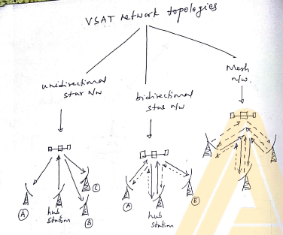
Regional Satellite Systems
One of the drawbacks of international satellite systems is that they are not optimized to the needs of the individual countries. Regional satellite missions were established with an aim of strengthening the communication resources of countries belonging to the same geographical area.
Examples:
- Eutelsat
- Arabsat
- Asiasat
- Measat
- Asia Cellular Satellite
- Thuraya
Eutelsat (European Telecommunication Satellite Organization)
This provides television, telephone and data transmission services on regional basis. 20 satellites in the GEO orbit operated by Eutelsat covering 98% of world population.
Eutelsat-1F series, Eutelsat-2F series and Eutelsat-W series have been launched. Eutelsat covers Europe, Asia and Africa.
National Satellite System:
This service refers to a domestic satellite system, provide services to a particular country. National satellite systems were originally developed/established by the United States, USSR and Canada, depending upon specific needs. Later developing countries like India, China, Japan etc. have their own satellite systems.
Examples:
- Galaxy, Satcom, Echostar, Telestar of U.S.
- Brasilsat of Brazil
- INSAT of India
- Optus of Australia
- Sinosat of China

INSAT (Indian National Satellite) is joint venture of Department of Space (DOS) of India, Dept. of Telecom of India (DOT), Indian Meteorological Dept. (IMD), All India Radio and Doordarshan (AIR).
Various series are:
- INSAT-1A, 1B, 1C, 1D
- INSAT-2A, 2B, 2C, 2D, 2E
- INSAT-3B, 3C, 3A, 3E
- INSAT-4A, 4B, 4CR
ACTIVITIES
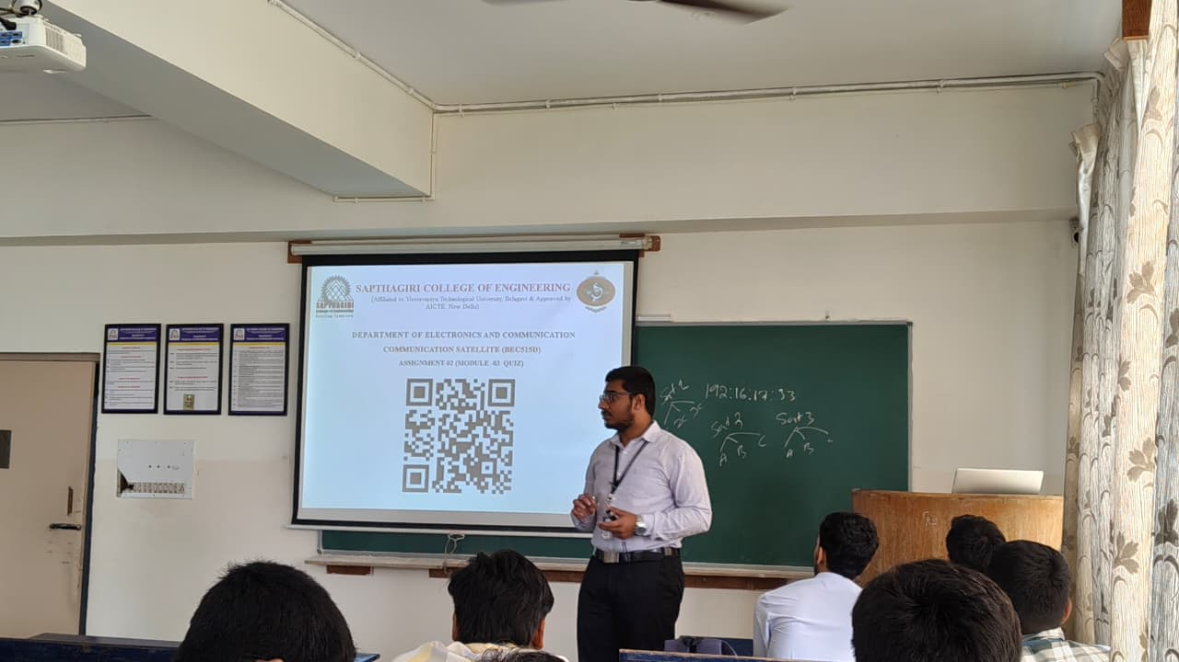
As part of the seminar on Communication Satellites, I also conducted a quiz session for the students in the class.
The quiz helped to reinforce the key concepts discussed during the presentation, such as satellite applications, frequency bands, and types of transponders.
It encouraged active participation, improved conceptual understanding, and made the session more interactive and engaging for all students.
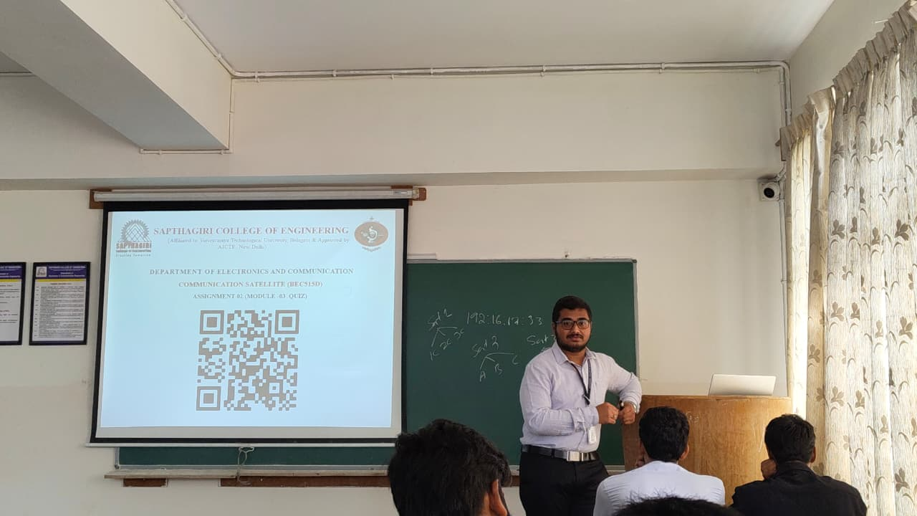

RESULTS AND ANALYSIS
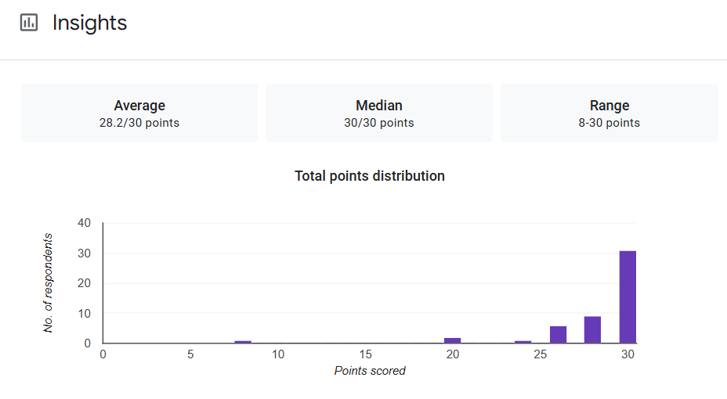
The quiz results demonstrate that students have gained a clear understanding of communication satellites, their applications, and technical aspects. The activity also encouraged active participation and reinforced learning outcomes.
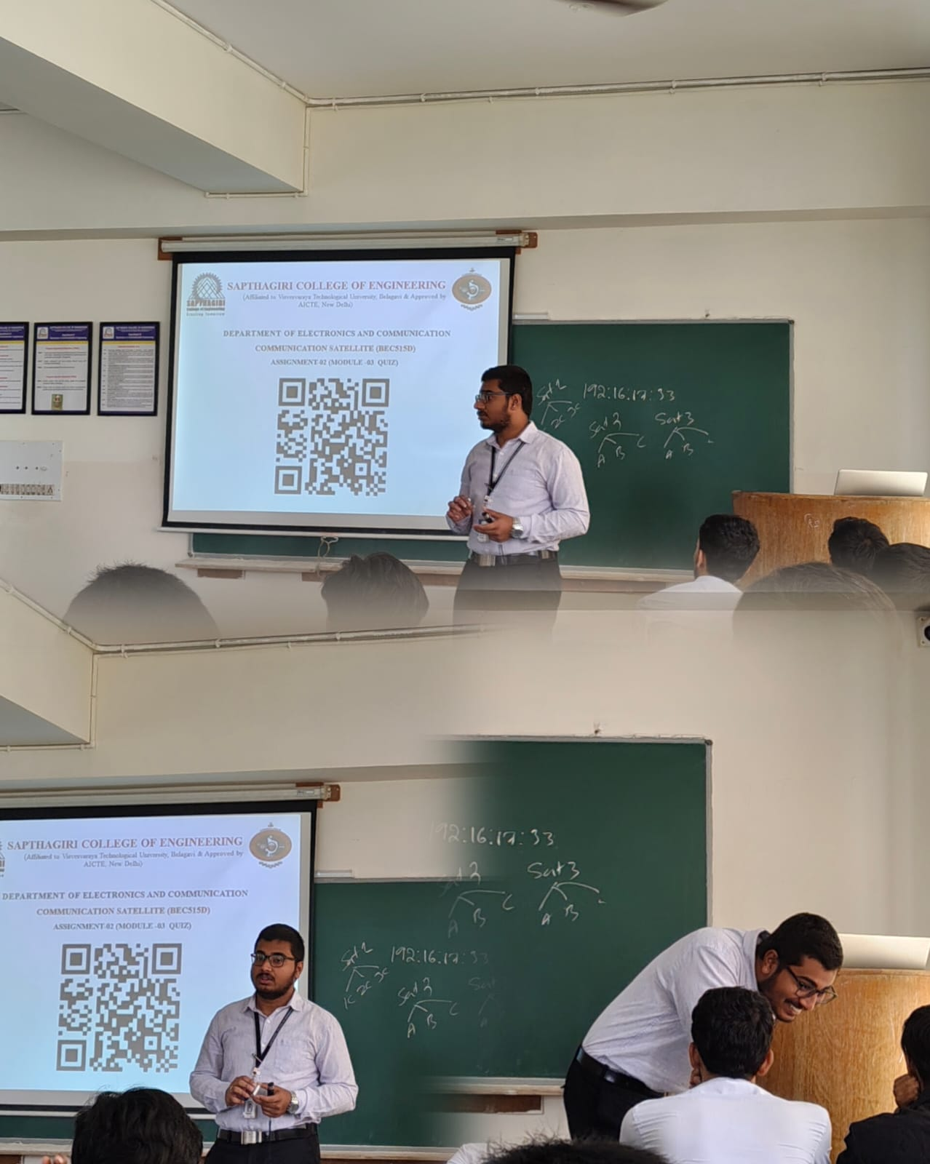
SEMINAR PHOTOS

CONCLUSION
Communication satellites play a crucial role in today’s world by enabling reliable long-distance communication, broadcasting, and data exchange. They act as repeater stations in space, linking remote areas and ensuring global connectivity where terrestrial networks cannot reach.
Through various frequency bands and transponder systems, satellites support vital applications such as television broadcasting, telephony, internet services, navigation, and data communication. The use of GEO, MEO, and LEO orbits has further expanded their efficiency and coverage.
With the advancement of technology, modern satellites like VSAT networks, DTH systems, and regional and national satellite programs (such as India’s INSAT series) have transformed communication infrastructure across the world.
In conclusion, communication satellites are the backbone of global communication systems, bridging distances, enhancing information exchange, and contributing significantly to education, defense, disaster management, and commercial services. Their continued development promises an even more connected and advanced future.

REFERENCES
[1] NASA – Satellite Communication Systems Overview, www.nasa.gov.
[2] Indian Space Research Organisation (ISRO) – INSAT System Information, www.isro.gov.in.
[3] International Telecommunication Union (ITU) – Satellite Network Regulations and Standards, www.itu.int.
[4] Module 3: Communication Satellites, Course Material.

